High School
Half Yearly Examination
2014
Year 10
Advanced
Mathematics Course
General Instructions  - Reading time: 5 minutes  - Working time: 2 hours  - There will be a short break between Section 1 and Section 2  - Write using black or blue pen  - You may use a pencil to draw or complete diagrams  - Attempt ALL questions  - Approved calculators may be used in Section 2.  - Write your Name and Teacher’s Name in the spaces provided.  - A formula Sheet is on the reverse of this page and can be detached and used in all sections of the test. | Total Marks – 100  Section 1  Non Calculator Section.  25 marks  Time allowed for this section is 30 minutes.  Write all answers in the spaces provided.  Section 2  Time allowed for this section is 1 hour and 30 minutes.  Part A  Multiple Choice Section.  Mark your answers on the separate answer sheet at the end of the examination.  50 marks  Part B  Longer Answer Section.  Write all answers in the spaces provided.  25 marks

Formula Sheet
Pythagoras’ Theorem
c = hypotenuse
a and b are the shorter sides

Circumference of a circle
d = diameter

Area of a circle
r = radius

Area of a parallelogram
b = base
h = perpendicular height

Area of a rhombus or kite
x and y are the diagonals

Area of a trapezium
h = perpendicular height
a and b are the parallel sides

Volume of a prism
A = area of base
h = perpendicular height

Volume of a pyramid
A = area of base
h = perpendicular height

Volume of a cylinder
r = radius
h = perpendicular height

Volume of a cone

Volume of a sphere
Surface Area of a Cylinder

Surface Area of Cone
r = radius
l = slant height

Surface Area of a sphere

Trigonometric formulae for a triangle ABC.

Sine Rule

Cosine Rule
or
Area of a triangle
Simple interest
P = Principal
R = interest rate per time period as a decimal
T = number of time periods

Compound Interest
A = Final amount to which the investment grows
P = Principal
r = interest rate per compounding period as a decimal
n = number of compounding periods
Depreciation
SV = Salvage Value to which the the initial value falls
IV = Initial Value
r = depreciation rate per compounding period as a decimal
n = number of compounding periods

Gradient of a line
and are points on the line
m = gradient

Midpoint of a line segment

Length of a line segment
Equation of a line
or
b = y intercept

Half-Yearly Examination
Advanced Mathematics

Class/Teacher ______________________

Name______________________

Section 1

25 marks
Time allowed for this section is 30 minutes

Answer Questions 1–25 in the spaces provided.

Calculators are NOT to be used in this section.

There will be a short break between Section 1 and Section 2.

Section 1 Non Calculator Section
 | Write all working and answers in the spaces provided on this test paper.
1. | 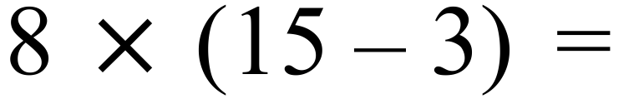  ……………………………………………………………………………………………………………  ……………………………………………………………………………………………………………
2. | 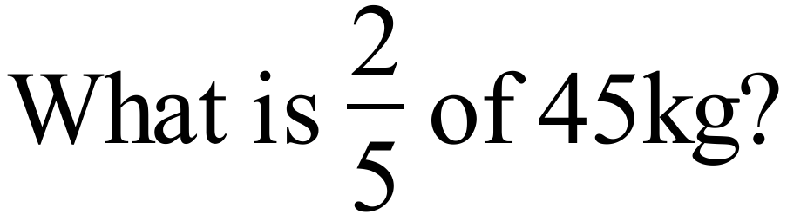  ……………………………………………………………………………………………………………  ……………………………………………………………………………………………………………
3. | 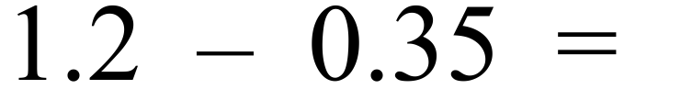  ……………………………………………………………………………………………………………  ……………………………………………………………………………………………………………
4. | Matthew is paid a commission of 6% of his sales; which are $2 400.  How much commission is he paid?  ……………………………………………………………………………………………………………  ……………………………………………………………………………………………………………
5. | Justin invests $600 in an account which pays 7% p.a. simple interest.  How much interest does he earn after 2 years?  ……………………………………………………………………………………………………………  ……………………………………………………………………………………………………………
6. | Acme Plumbing buys a trencher for $60 000 and sells it later for $45 000.  What percentage loss did they make when they sold the trencher?  ……………………………………………………………………………………………………………  ……………………………………………………………………………………………………………
7. | Simplify the ratio 4.5 kilograms : 750 grams.  ……………………………………………………………………………………………………………  ……………………………………………………………………………………………………………
8. | 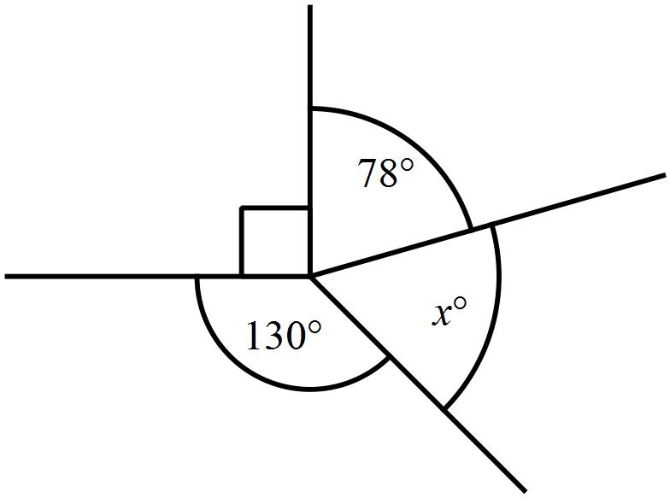What is the value of x in the diagram?  …………………………………………………  …………………………………………………  …………………………………………………  …………………………………………………
9. | What is the value of x in the diagram?  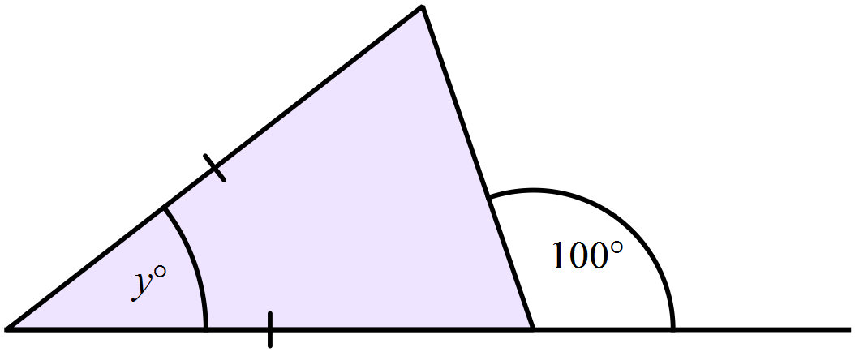…………………………………………………  …………………………………………………  …………………………………………………    …………………………………………………
10. | …………………………………………………
  Nick is looking at the properties of a particular quadrilateral. He records his observations in the table.  What name would describe the quadrilateral accurately? | Property | Yes /No
   | All sides equal | Y
   | All angles equal | N
   | Diagonals are equal | N
   | Diagonals intersect at right angles | Y
   | Axes of symmetry | Y (2)
11. | A can of cola holds 375 ml.  How many litres would a pack of 10 cans hold?  …………………………………………………………………………  …………………………………………………………………………  …………………………………………………………………………  …………………………………………………………………………
12. | 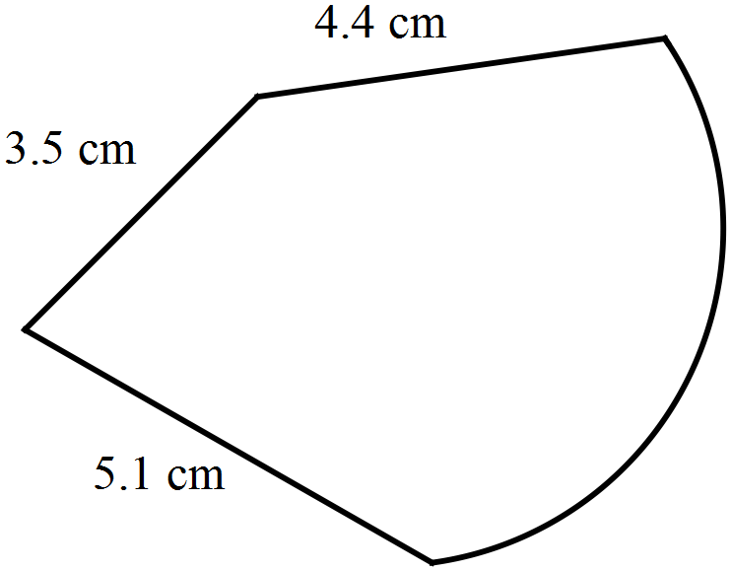The perimeter of the shape shown is 20.4 cm.  What is the length of the curved part?  ………………………………………………  …………………………………………………  …………………………………………………  …………………………………………………
13. | Find the area of the quadrilateral below.  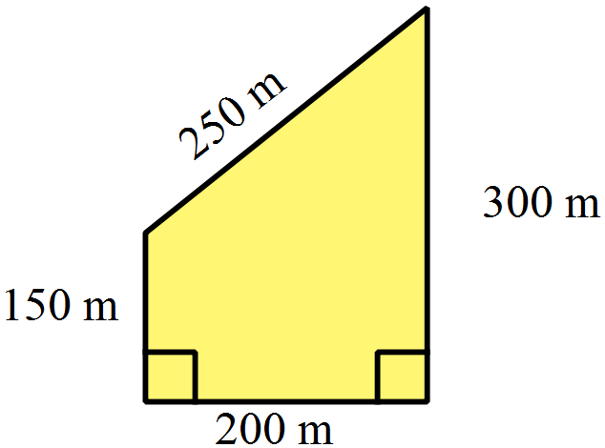  …………………………………………………  …………………………………………………  …………………………………………………  …………………………………………………
14. | 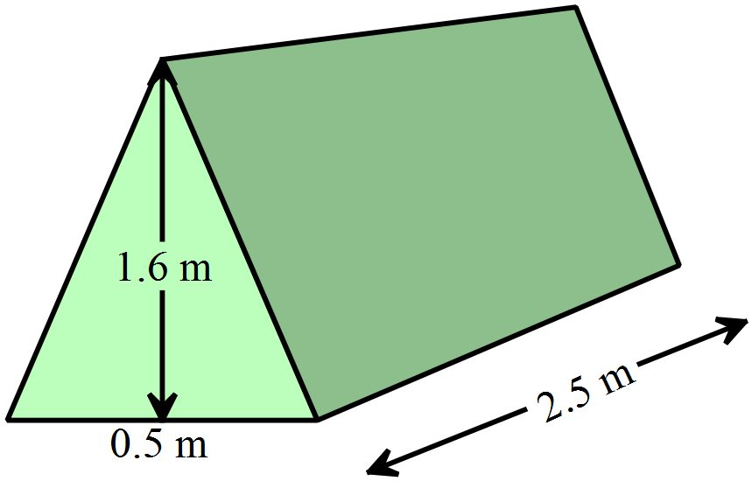What is the volume of the triangular prism below?  ………………………………………………  ………………………………………………  ………………………………………………  ………………………………………………
15. | What is the length of MN in the triangle LMN?  Leave your answer as a surd.  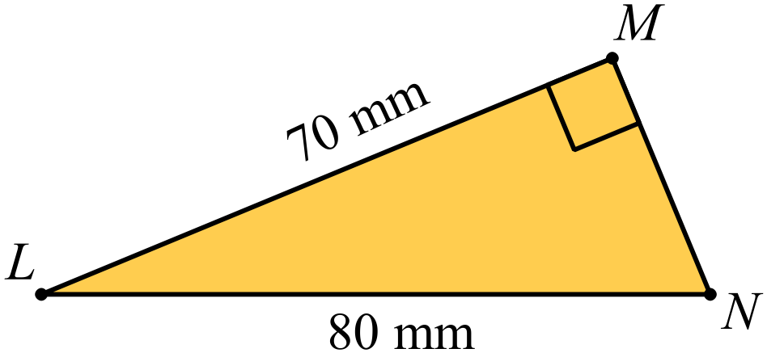  …………………………………………………  …………………………………………………  …………………………………………………  …………………………………………………
16. | Simplify 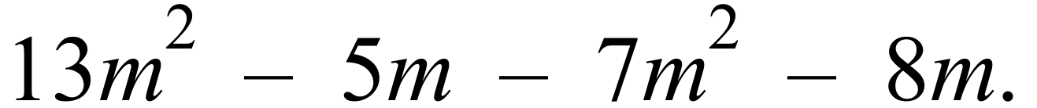  ……………………………………………………………………………………………………………
17. | 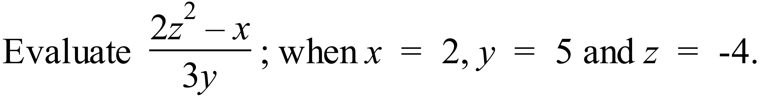  ……………………………………………………………………………………………………………  ……………………………………………………………………………………………………………
18. | Expand and simplify  ……………………………………………………………………………………………………………  ……………………………………………………………………………………………………………
19. | 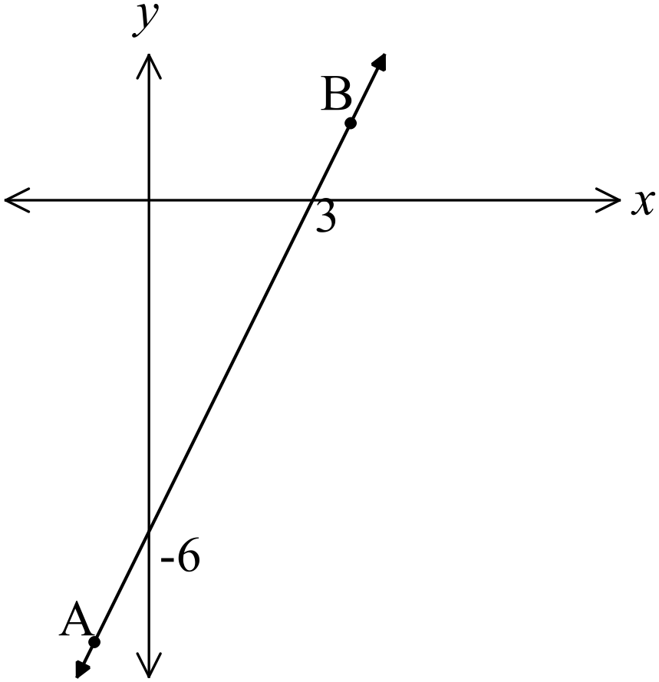What is the gradient of the line AB?  ………………………………………………  ………………………………………………  ………………………………………………  ………………………………………………
20. | Evaluate 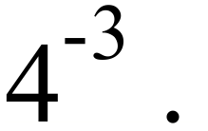  ……………………………………………………………………………………………………………
21. | Solve 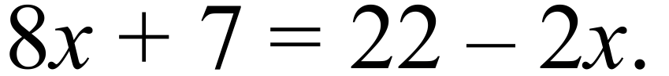  ……………………………………………………………………………………………………………  ……………………………………………………………………………………………………………
22. | 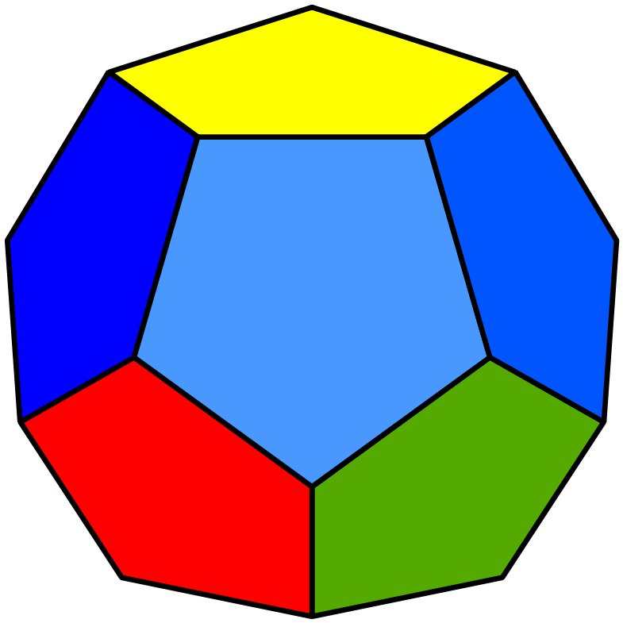A 12 sided die has 2 faces coloured yellow, 2 green, 5 blue and the remainder red.  What is the probability that a red side finishes facing up?  ………………………………………………………………  ………………………………………………………………
Questions 23 and 24 refer to the sector graph below.
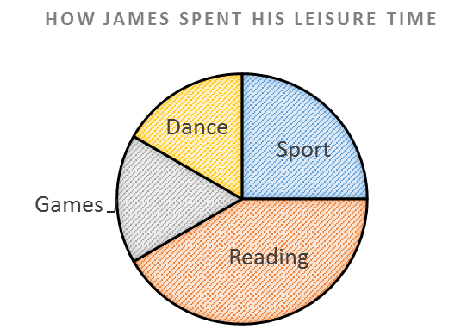

23. | Which activities took up 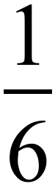 of his leisure time?  ……………………………………………………………………………………………………………  ……………………………………………………………………………………………………………
24. | James spent 6 hours a week playing sport.  How many hours did he spend reading?  ……………………………………………………………………………………………………………  ……………………………………………………………………………………………………………
25. | The dot plot shows the hours spent volunteering in a week by a group of friends.  What was the median number of hours spent volunteering?  ……………………………………………………………………………………………………………  ……………………………………………………………………………………………………………
   |  |  | O
  O |  | O | O
  O |  | O | O | O
  O | O | O | O | O
  O | O | O | O | O | O |  |  | O
  0 | 1 | 2 | 3 | 4 | 5 | 6 | 7 | 8
 | End of Section 1

Half-Yearly Examination
Advanced Mathematics

Section 2

75 marks
Time allowed for this section is
1 hour and 30 minutes

This section has TWO parts

Part A – Fifty multiple-choice questions worth 1 mark each.
Mark your answers on the separate answer sheet provided at the end of the examination.
Part B – Longer answer questions worth a total of 25 marks.
Write all answers and working in the spaces provided on this examination paper.

Calculators may be used in this section.

Do not commence Section 2 until you are instructed to do so.

Use the multiple choice answer sheet at the end of the paper to record your answers.
Completely shade the bubble corresponding to the correct answer for each question.

26. | What positive integers less than 10 could be written in the spaces marked ⌂ and □ to make the subtraction true?  A. ⌂ = 7 and □ = 6 B. ⌂ = 6 and □ = 7  C. ⌂ = 3 and □ = 3 D. ⌂ = 7and □ = 7
   |  | 7 | 4 | 5 | –
   |  | 2 | □ | 8
   |  | 4 | 7 | ⌂
27. | Michaela invests $6 500 at 4.25% p.a. simple interest for a period of 18 months. How much interest does she earn?  A. $414.38 B. $828.75 C. $621.56 D. $4 972.50
28. | A Notebook Computer is advertised as shown.  Notebook Computer  Cash Price - $1600  or  $342 deposit  and $70 per  month for 24 months  How much extra is paid by paying it off over 24 months, compared to the cash price?  A. $272 B. $422 C. $1 872 D. $2 022
29. | Use the compound interest formula to find the value of a $12 000 investment earning interest at 7% p.a. compounding annually for 4 years.  A. $3 600.00 B. $3 729.55 C. $15 360.00 D. $15 729.55
30. | When Peter won $2 500 in a lottery, he kept half and divided the rest between his sons Braiden and Trent in the ratio 3 : 2.  How much does Trent receive?  A. $500 B $750 C. $1 000 D. $1 500
31. | 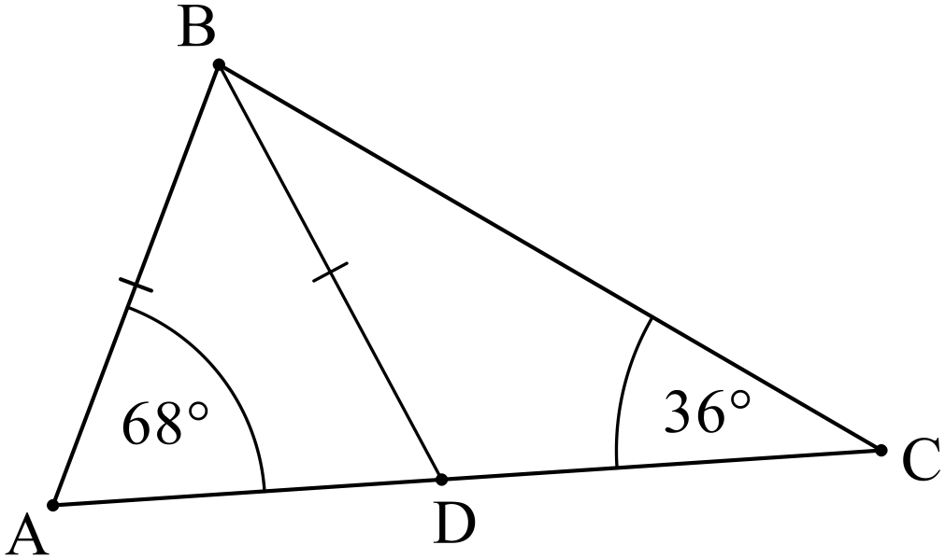What is the size of   A. 32º B. 44º  C. 68º D. 76º
32. | A parallelogram ABCD has both its diagonals drawn, intersecting at E.  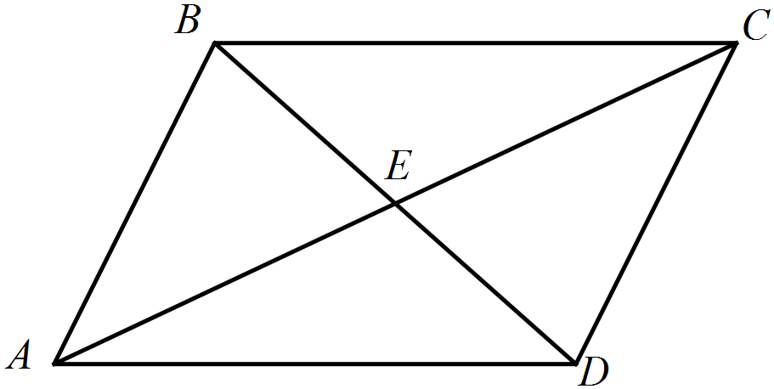  Which pair of triangles are congruent?  A.   B.   C.  D. 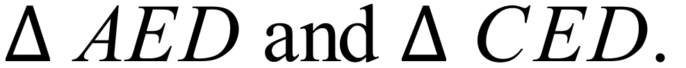
33. | 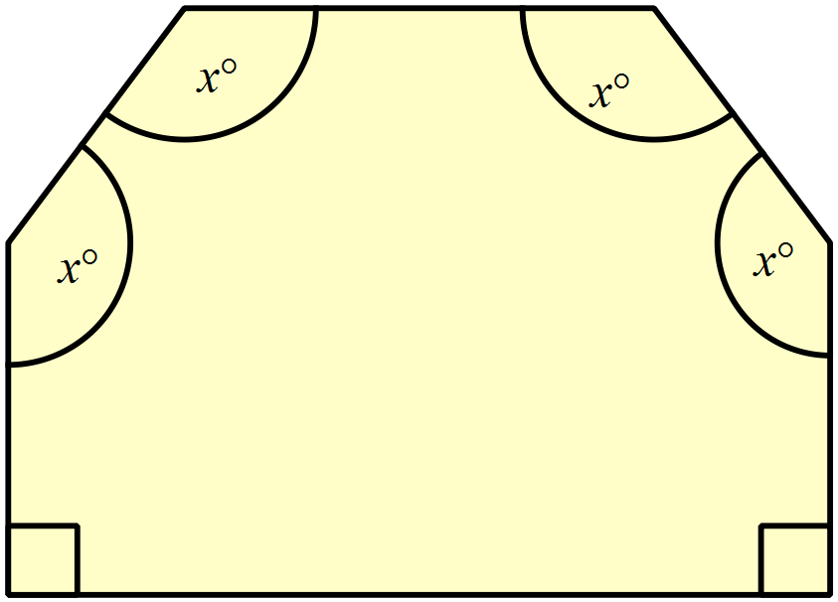There are two right angles and four angles which are equal to xº in the irregular hexagon shown.  What is the value of x?  A. 115º  B. 120º  C. 135º  D. 150º
34. | Theo makes two statements about the figure below.  - The figure has exactly two axes of line symmetry.  - The figure has rotational symmetry of order four.  Which is true?  A. Both statements are true.  B. Neither statement is true.  C. Only statement I is true.  D. Only statement II is true.
35. | 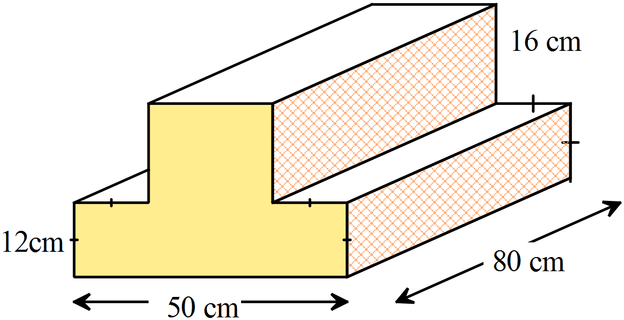Find the volume of the prism shown.  A. 1 016 cm³  B. 8 128 cm³  C. 10 160 cm³  D. 81 280 cm³
36. | Find the surface area of the triangular prism shown.  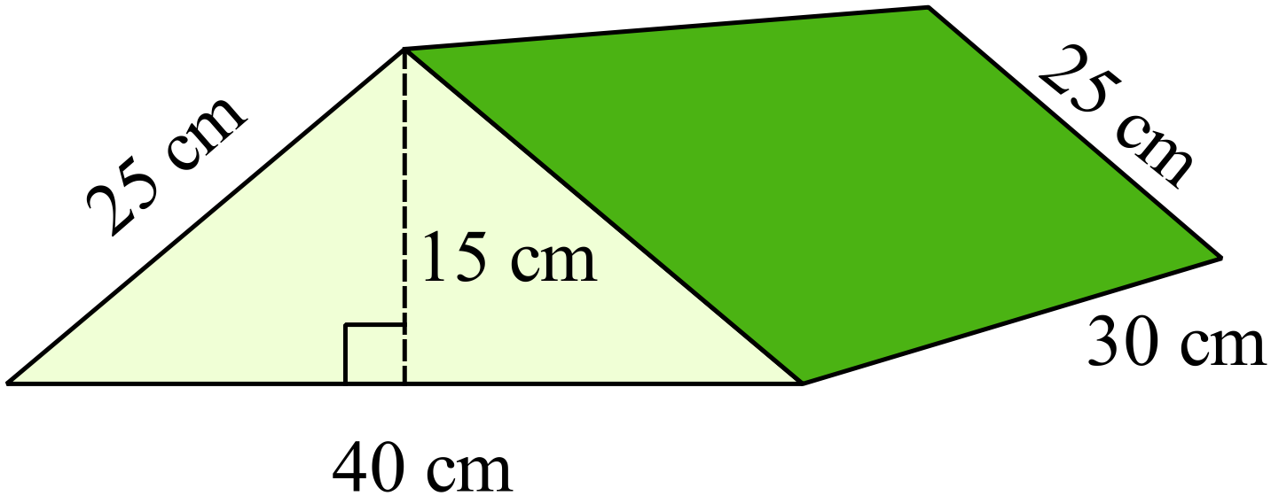  A. 2 100 m²  B. 3 000 m²  C. 3 300 m²  D. 9 000 m²
37. | 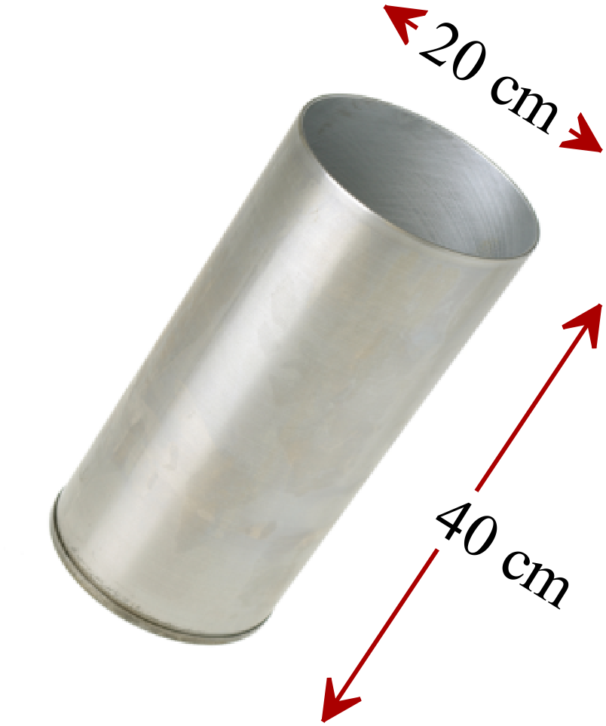A cylindrical metal container has a diameter of 20 cm and a depth of 40 cm and is open at one end.  Find the area of metal used to make the beaker.  A. 628 cm²  B. 2 512 cm²  C. 2 827 cm²  D. 3 140 cm²
38. | If 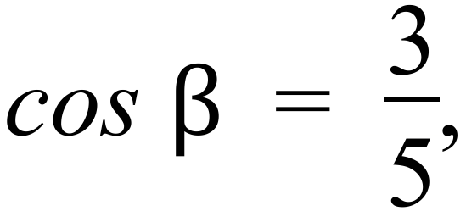 what is the size of angle 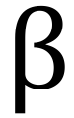 to the nearest degree?  A. 31 º B. 37 º C. 53 º D. 59º
39. | 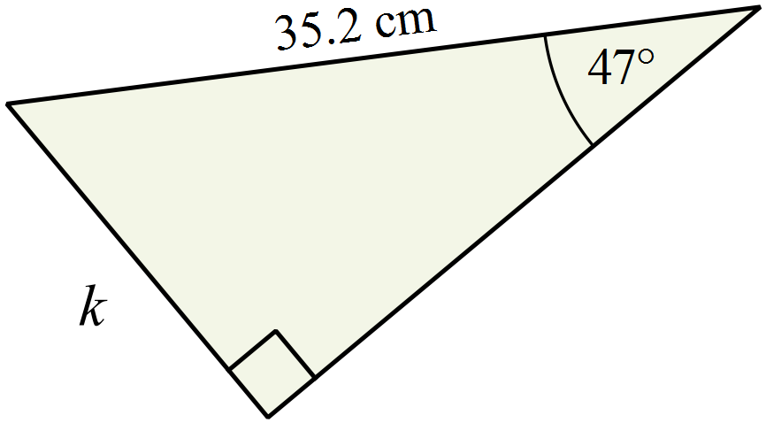Find the value of k, correct to one decimal place.  A. 25.7 cm  B. 37.7 cm  C. 47.0 cm  D. 48.1 cm
40. | 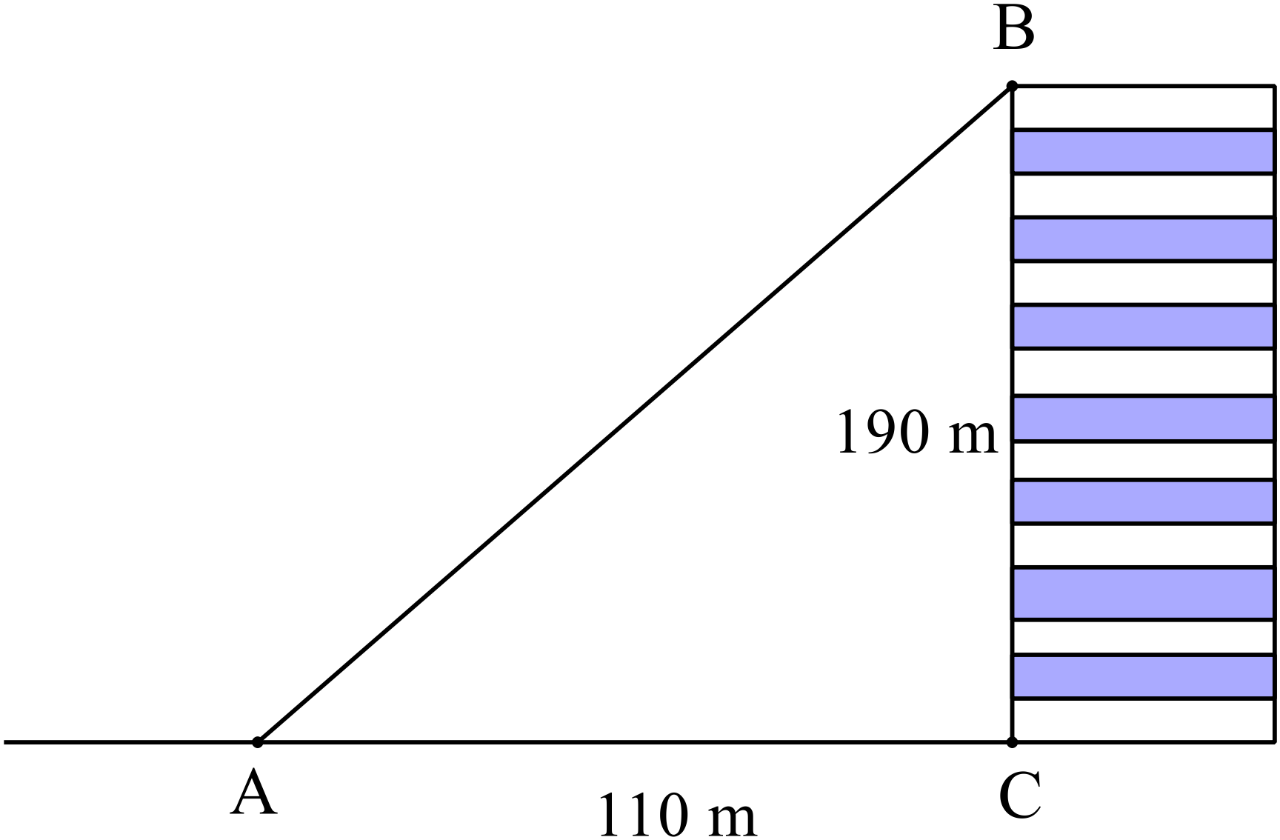What is the angle of elevation of B from A?  A. 30º  B. 60º  C. 75º  D. 85º
41. | Which term below is not a factor of 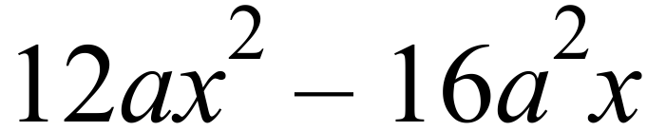  A. 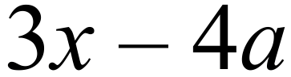 B. 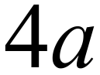 C. 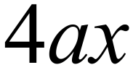 D. 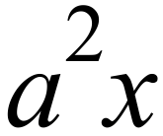
42. | A line has a gradient of and passes through the point 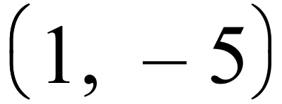 . What is its equation?  A. 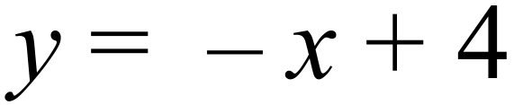  B. 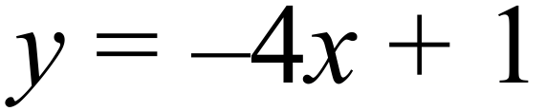  C. 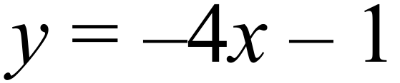  D. 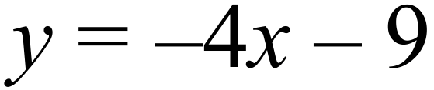
43. | 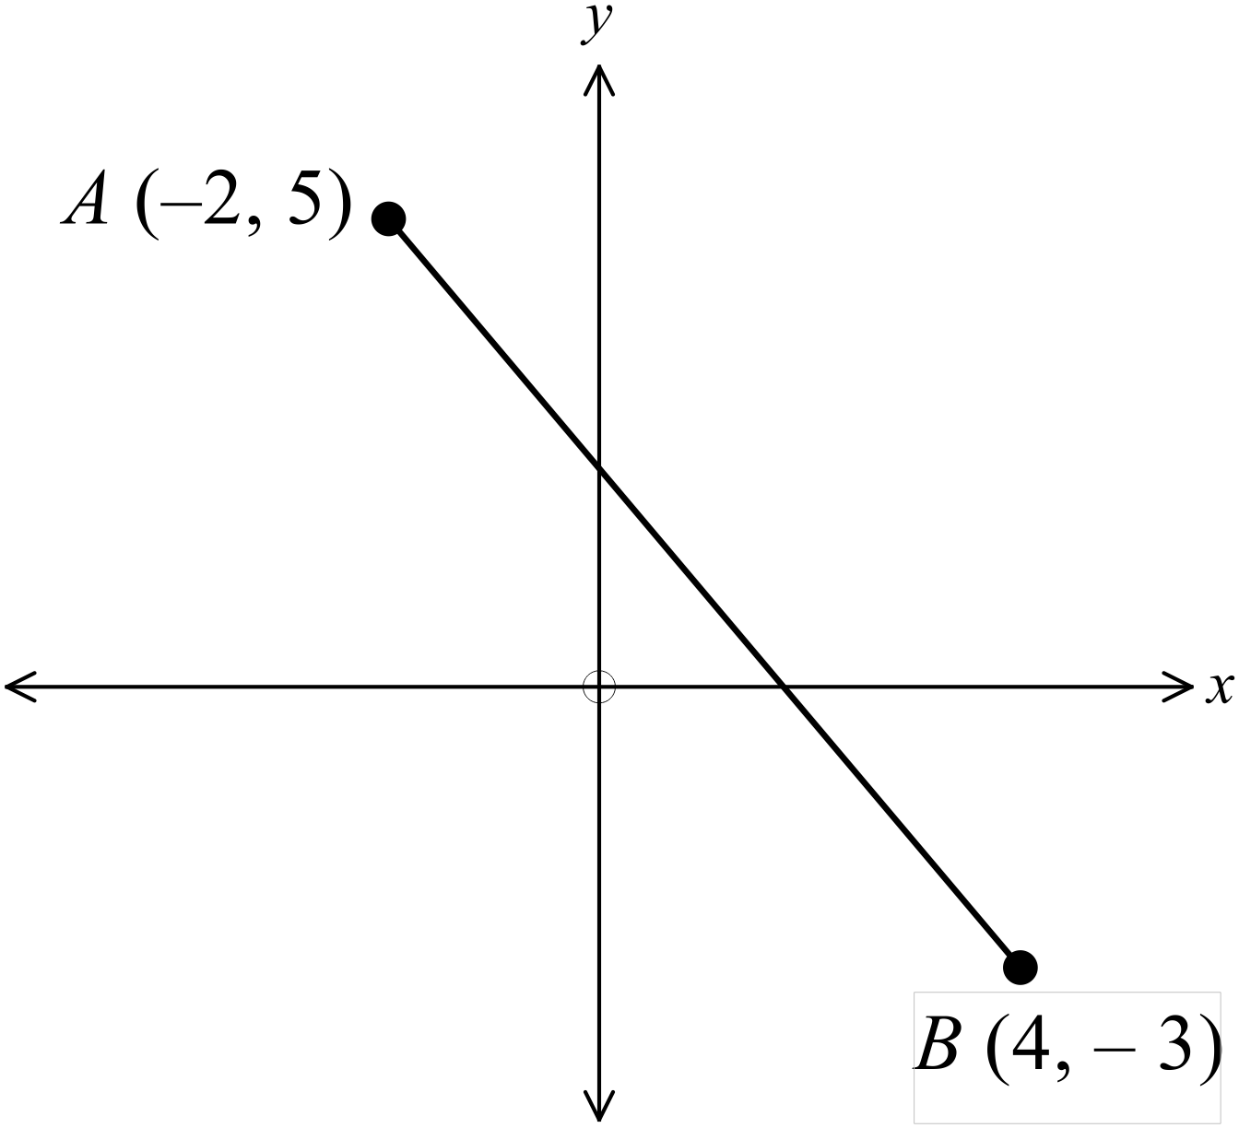What is the length of the interval AB?  A. 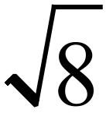 units  B. 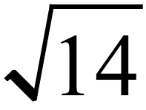 units  C. 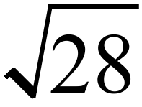 units  D. 10 units
44. | 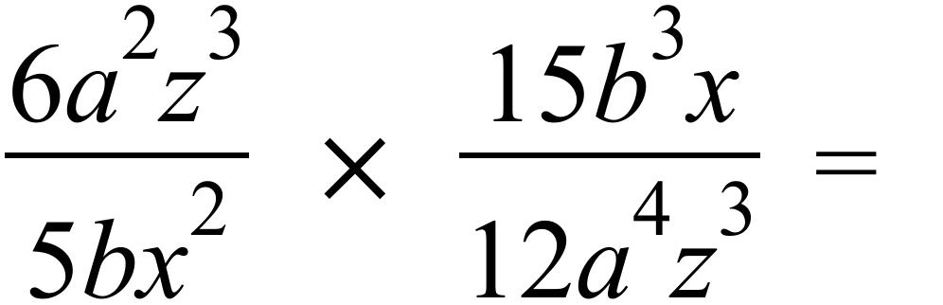  A. 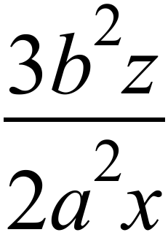 B. 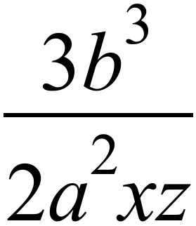 C. 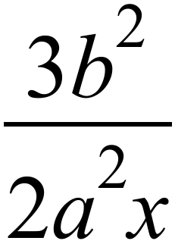 D. 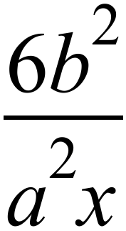
45. | What is the solution to the equation 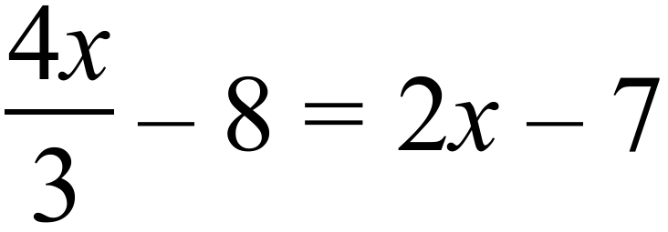 ?  A. 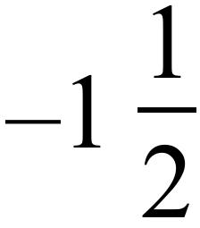 B. 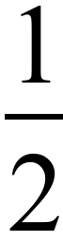 C. 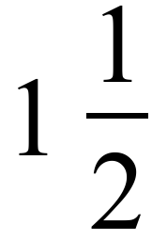 D. 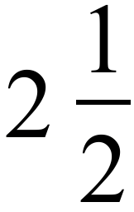
Questions 46 – 48 refer to the stem and leaf plot.

The coach of the Emattogah Cricket Club compiles the stem and leaf plot showing the ages of their players.
Ages of Emattogah Cricket Players
1 | 4 | 5 | 6 | 6 | 8 | 9
2 | 0 | 2 | 4 | 6 | 7 | 9 | 9 | 9
3 | 1 | 3 | 4 | 5 | 5 | 7
4 | 2 | 6
5 | 3

46. | How many players are there in the club?  A. 22 B. 23 C. 24 D. 28
47. | What is the median age of the players?  A. 27 B. 28 C. 29 D. 30
48. | What is the upper quartile of their ages?  A. 34.5 B. 35 C. 36 D. 37
Questions 49 – 50 refer to the following dot plot.
Frequency
Frequency |  | O |  |  |  |  |  | O
Frequency |  | O |  |  |  |  |  | O
Frequency |  | O | O |  |  |  | O | O
Frequency | O | O | O | O |  | O | O | O | O
Frequency | O | O | O | O | O | O | O | O | O
Frequency | 1 | 2 | 3 | 4 | 5 | 6 | 7 | 8 | 9
Frequency | Score

49. | Which two terms could be applied to describe the distribution?  A. Bimodal and Skewed  B. Bimodal and Symmetrical  C. Unimodal and Skewed  D. Unimodal and Symmetrical
50. | Which would be true of the distribution.  A. The mean and mode would be equal.  B. The mean and range would be equal.  C. The mean and median would be equal.  D. The median and mode would be equal.
51. | Which calculation would you use to find the amount that $26 000 grows to when invested at 6% p.a. interest compounding monthly for one and a half years.  A. 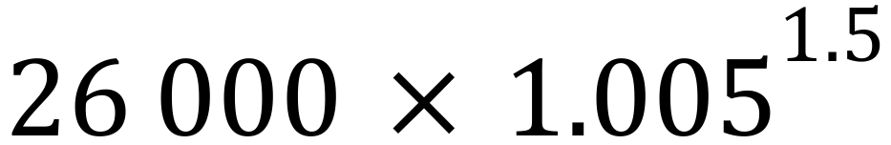 B. 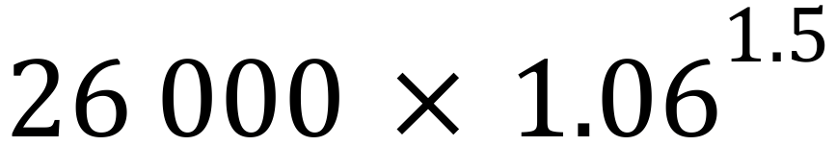  C. 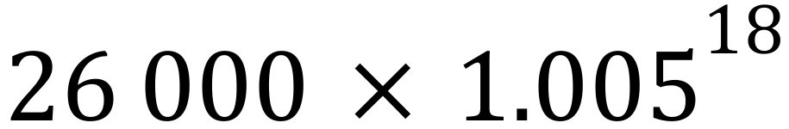 D. 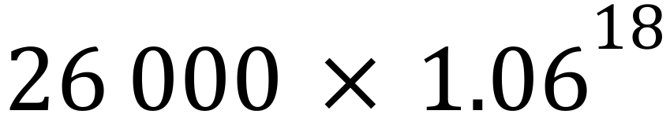
52. | Petra buys a laptop for $2 500. It depreciates at a rate of 15% p.a. compounding annually. What is the value (to the nearest dollar) of the laptop after three years?  A. $965 B. $1 375 C. $1 535 D. $2 125
53. | 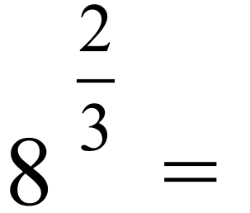  A. 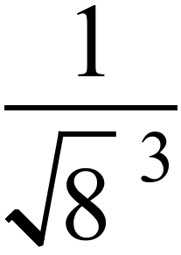 B. 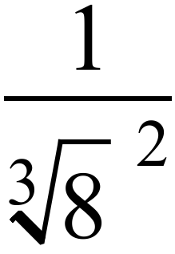 C. 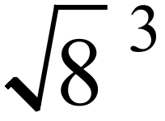 D. 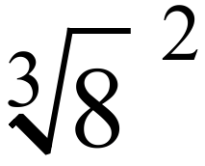
54. | Completely simplify 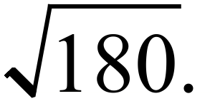  A. 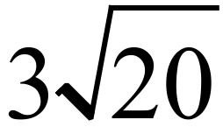 B. 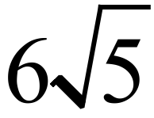 C. 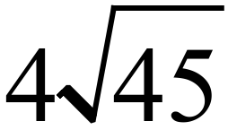 D. 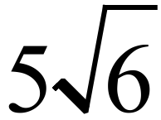
55. | Expand and completely simplify 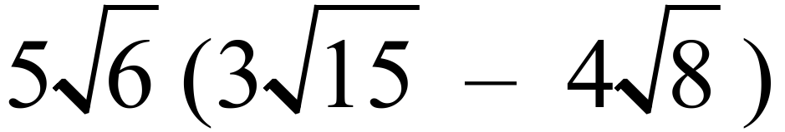.  A. 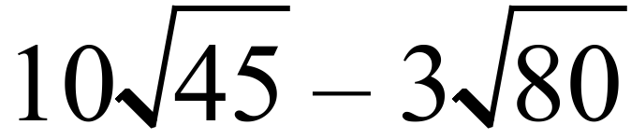 B. 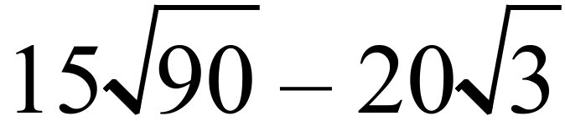 C. D. 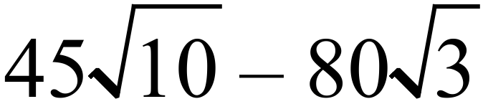
56. | 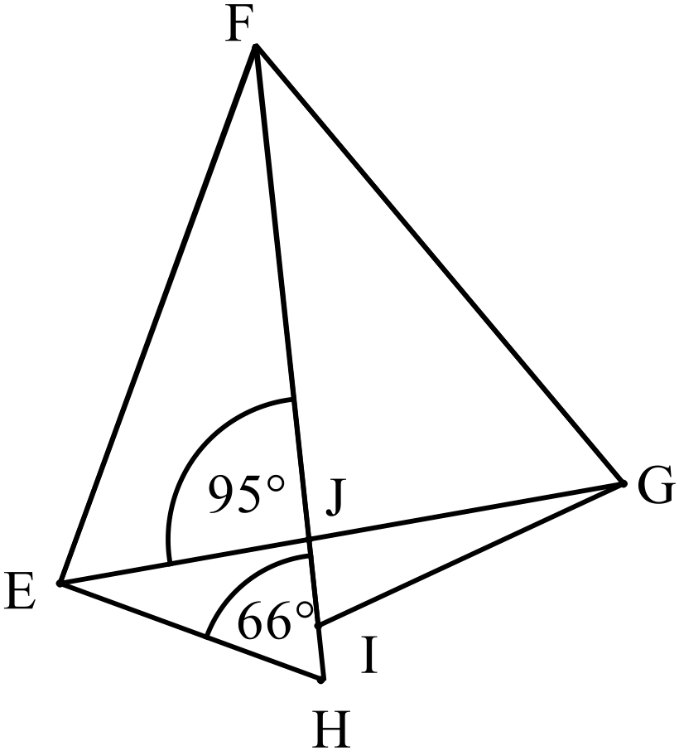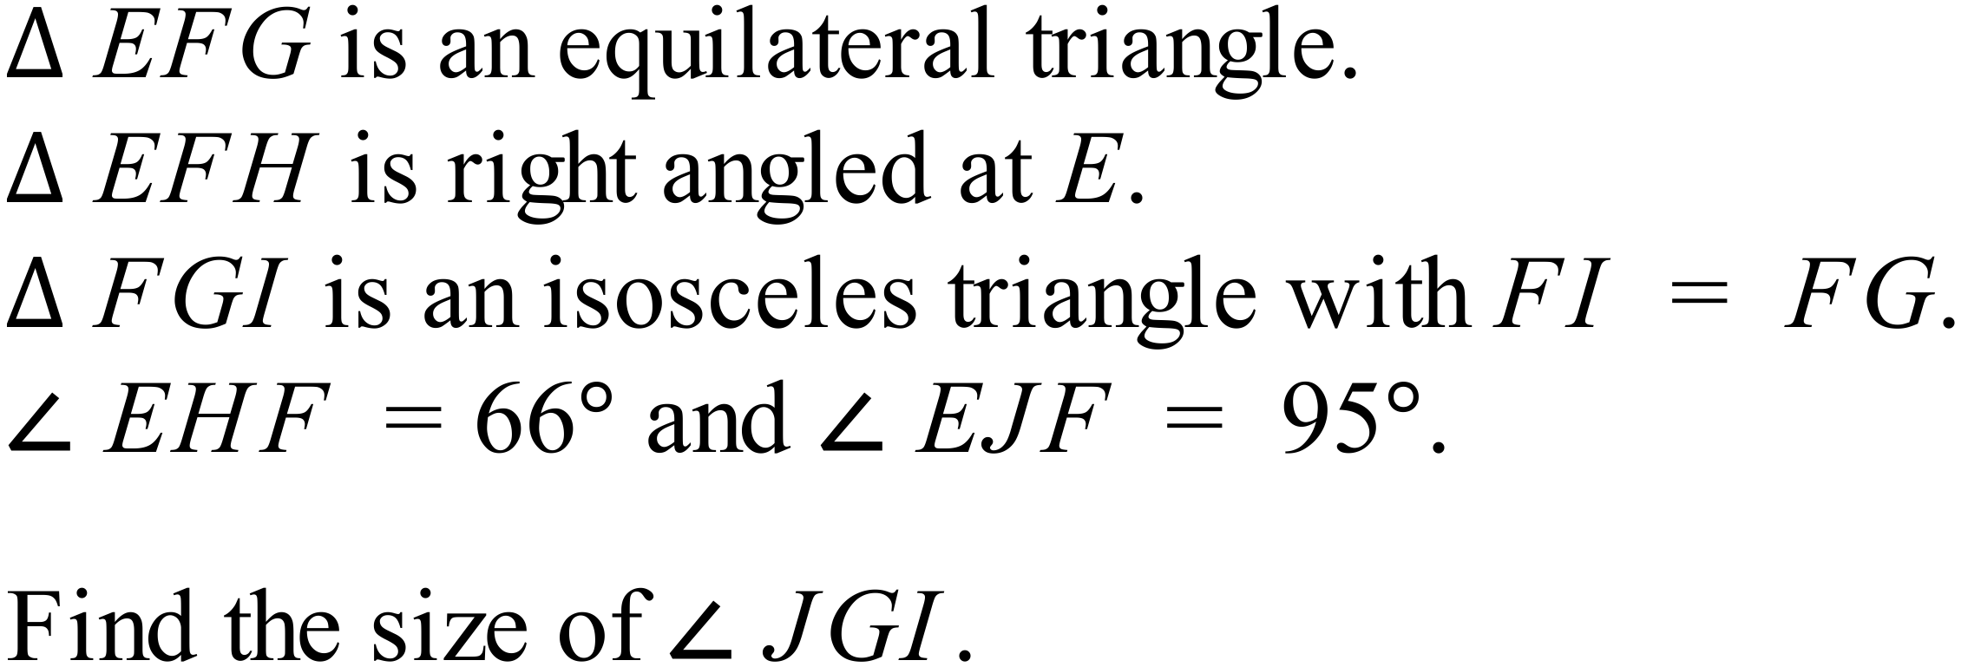  A. 13º  B. 24º  C. 36º  D. 66º
57. | 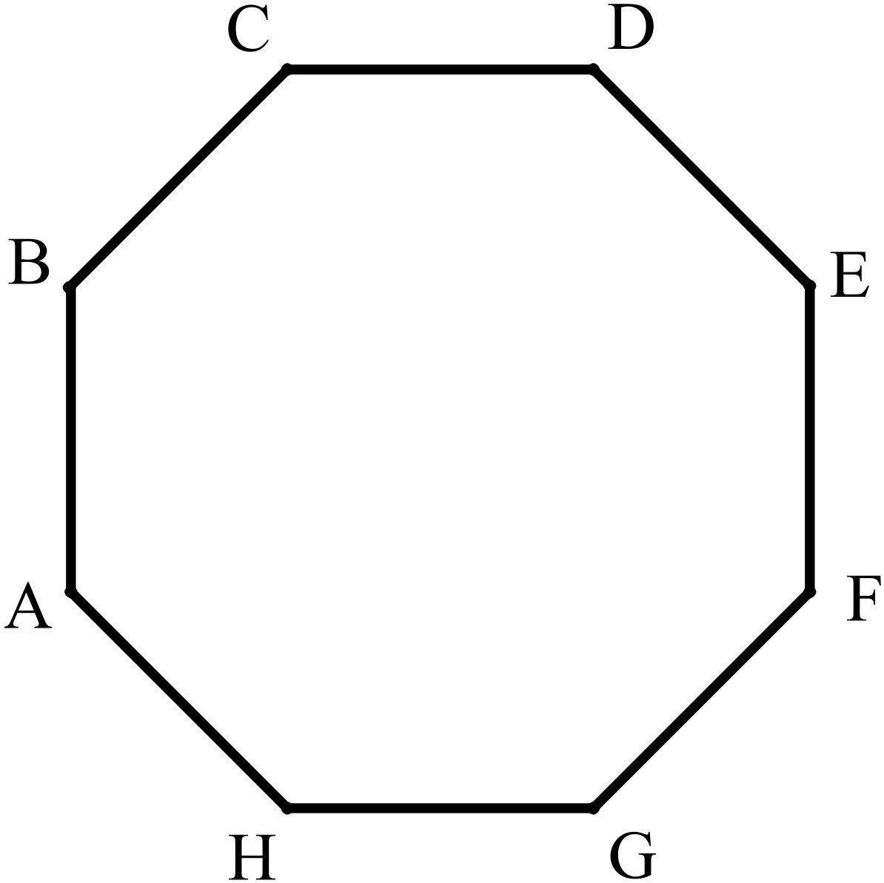The figure shown is a regular octagon.  Which of the following is not true?  A. Quadrilateral ABCH is a trapezium.  B. Angle ABC = 120º  C. Triangle ABC is isosceles.  D. Quadrilateral ABEF is a rectangle.
58. | 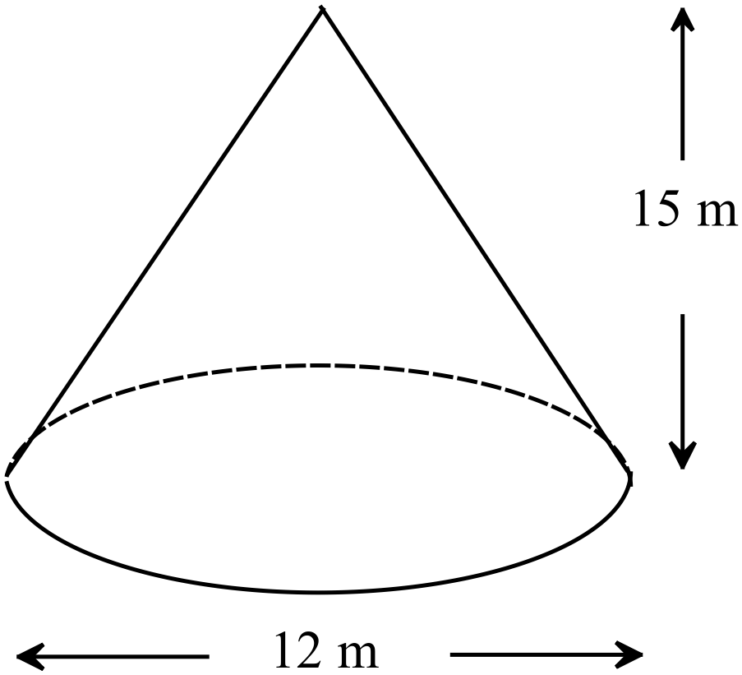What is the volume of this cone (in terms of 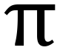 )?  A. 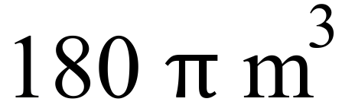  B. 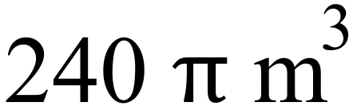  C. 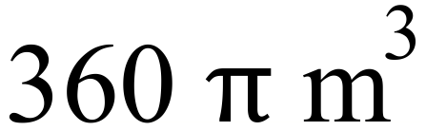  D. 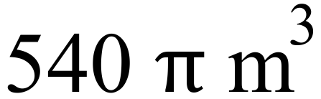
59. | 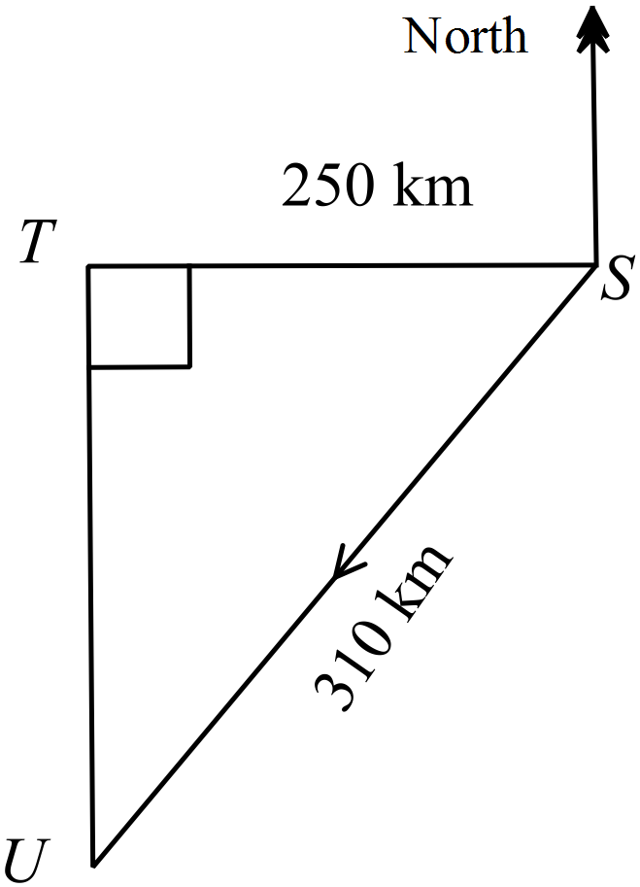Smithtown (S) is 250 km due east of Tunbridge (T).  Uxbridge (U) is due south of Tunbridge,  A plane flies 310 km from Smithtown to Uxbridge.  On what bearing does the plane fly?  A. 216º  B. 231º  C. 234º  D. 306º
60. |   The game of pool uses a set of 15 numbered balls which are solid, hard plastic spheres which are 6 cm in diameter.  One cubic centimetre of the plastic has a mass of 1.5 grams.  What is the mass of the set of 15 balls?  A. 1.13 kg  B. 1.70 kg  C. 1.91 kg  D. 2.54 kg
61. | 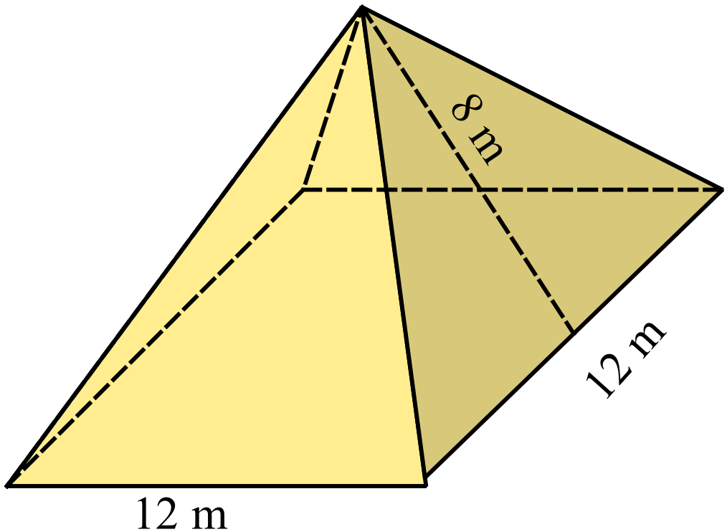A theatre company are building a square pyramid as a backdrop for a performance.  The base edges are 12 m and the slant heights of the triangular faces are all 8 m.  It is to be hollow and made of canvas, with no base.  What area of canvas is needed?  A. 192 m² B. 240 m² C. 336 m² D. 384 m²
62. | 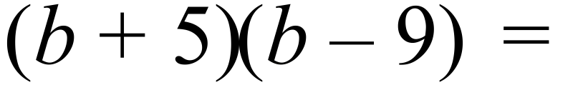  A. 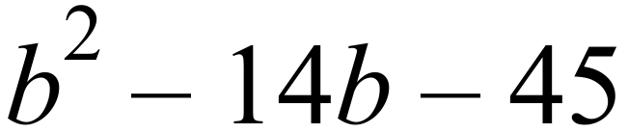 B. 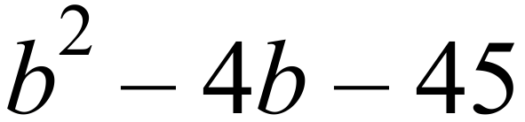  C. 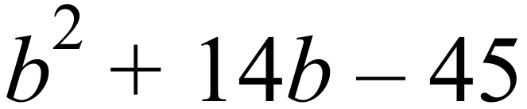 D. 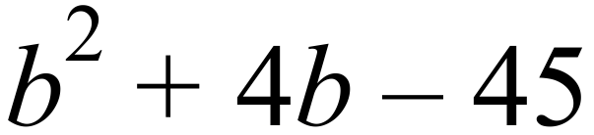
63. | 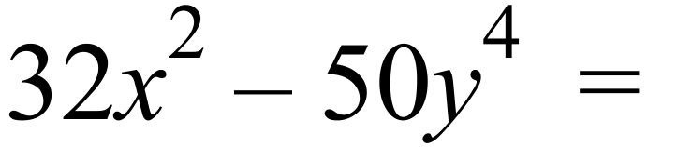  A. 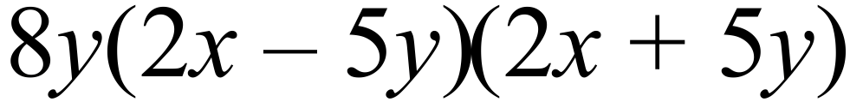 B. 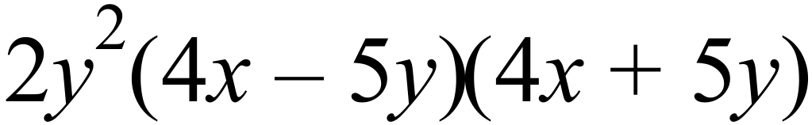  C. 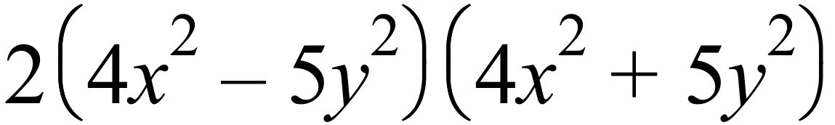 D. 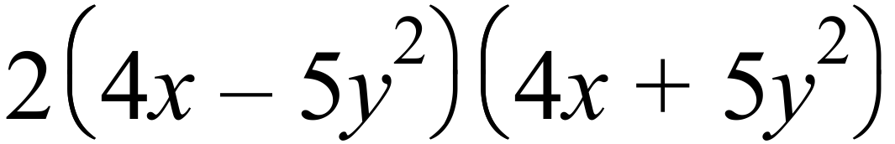
64. | 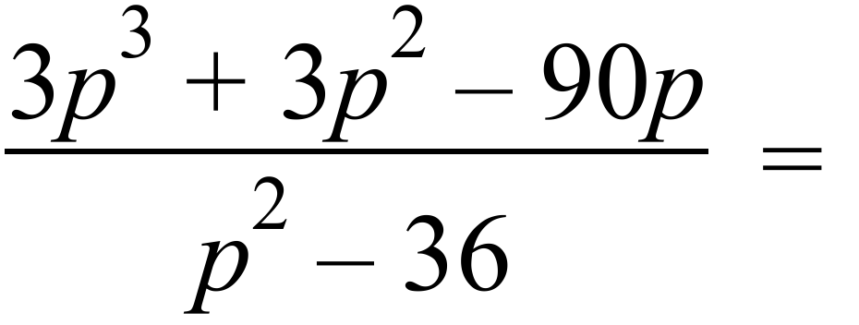  A. 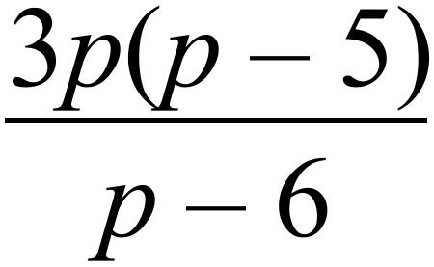 B. 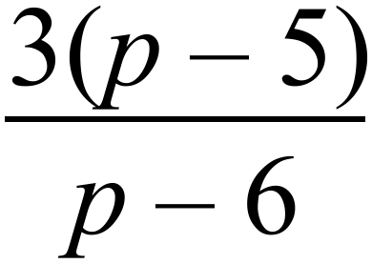  C. 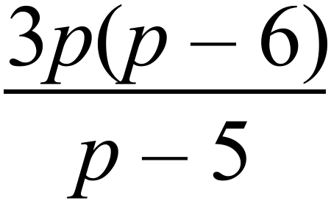 D. 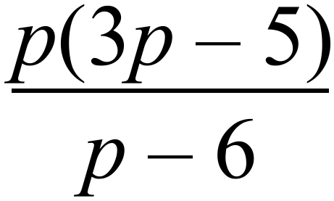
65. | The solution to a pair of simultaneous equations is shown:  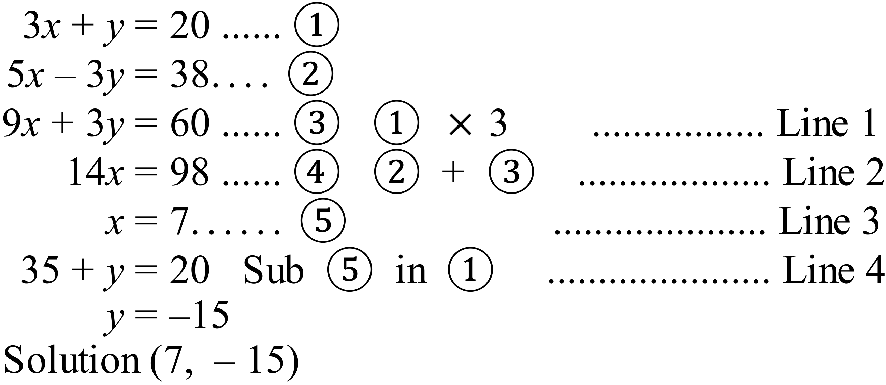  In which line does a mistake occur?  Line 1 B. Line 2 C. Line 3 D. Line 4
66. | 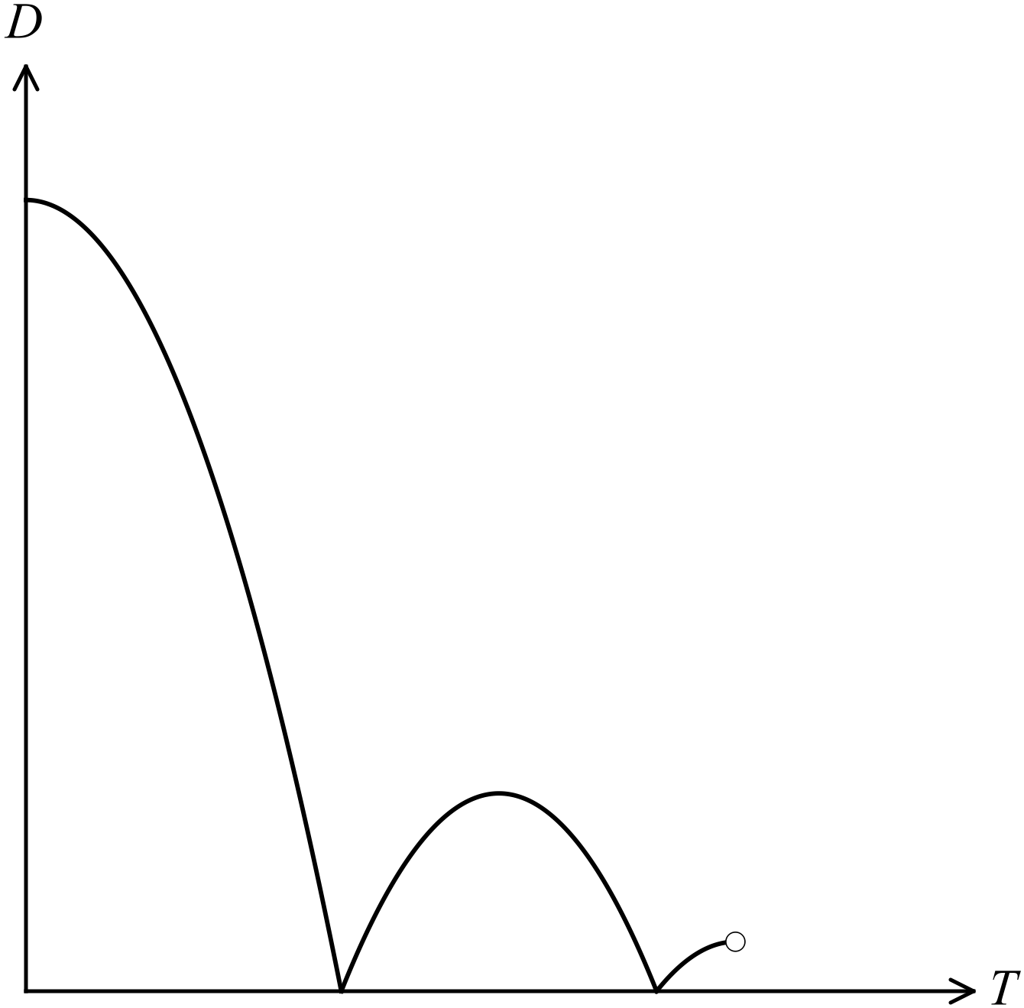The graph shown compares distance (D) and time (T) for a ball in motion.  Which of the following explanations could describe the motion?  A. The ball is thrown in the air, returns to the ground and bounces twice before being caught by a student in the playground.  B. The ball is thrown in the air, returns to the ground and bounces twice before coming to a stop on the ground.  C. The ball is dropped from a high window, falls to the ground and bounces twice before being caught by a student in the playground.  D. The ball is dropped from a high window, falls to the ground and bounces twice before coming to a stop on the ground.
67. | Solve : 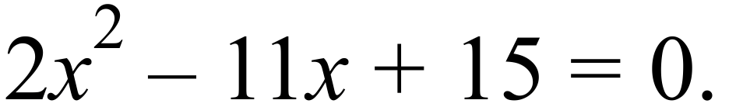  A. 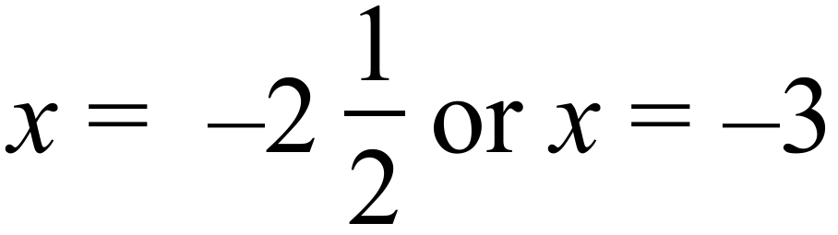 B. 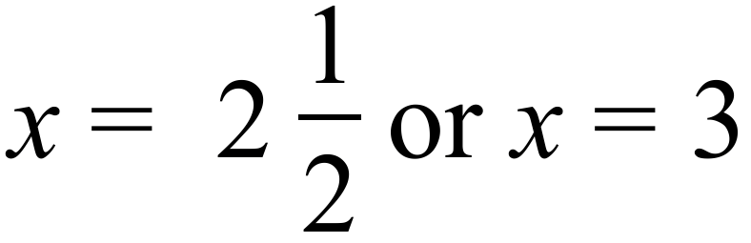  C. 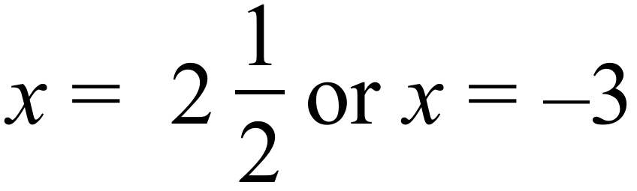 D. 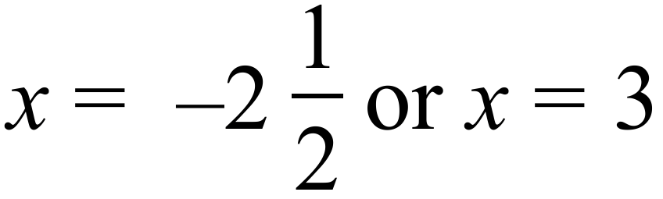
68. | A. 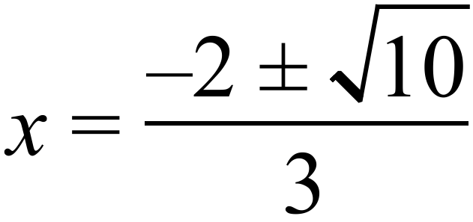 B. 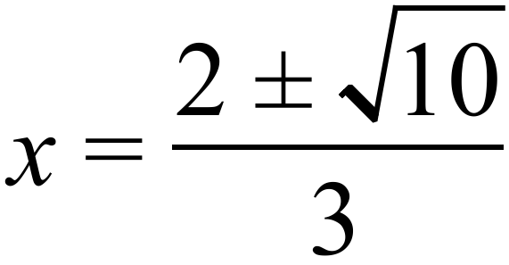 C. 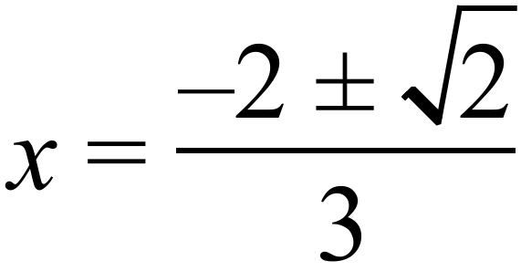 D. 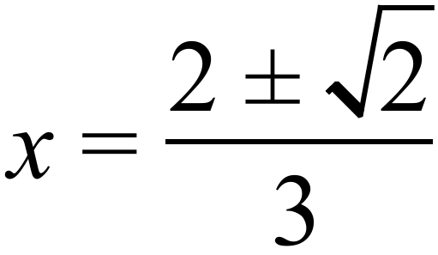
69. | Which of these is the graph of 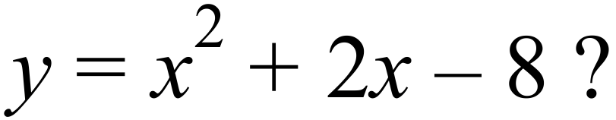  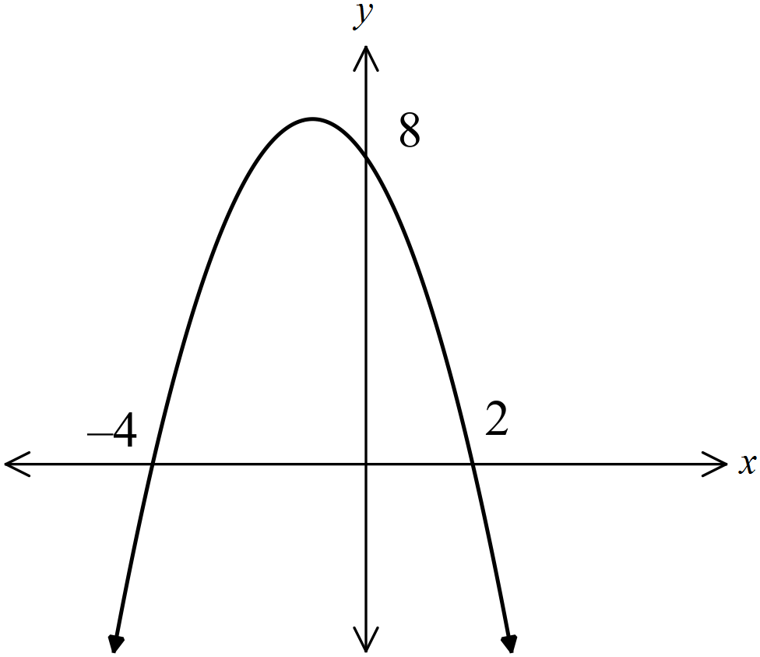  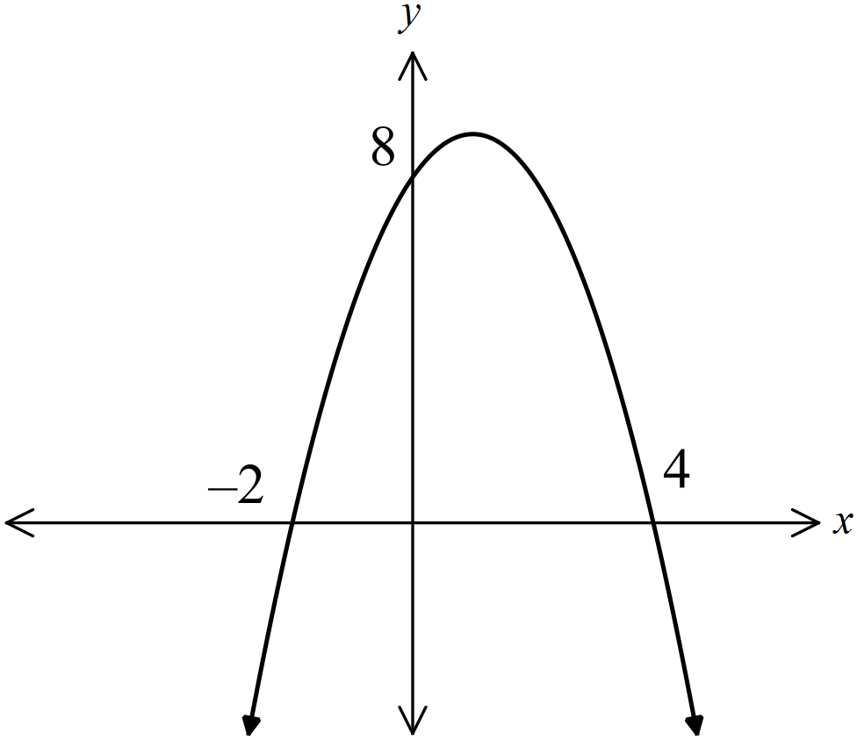 A. B.  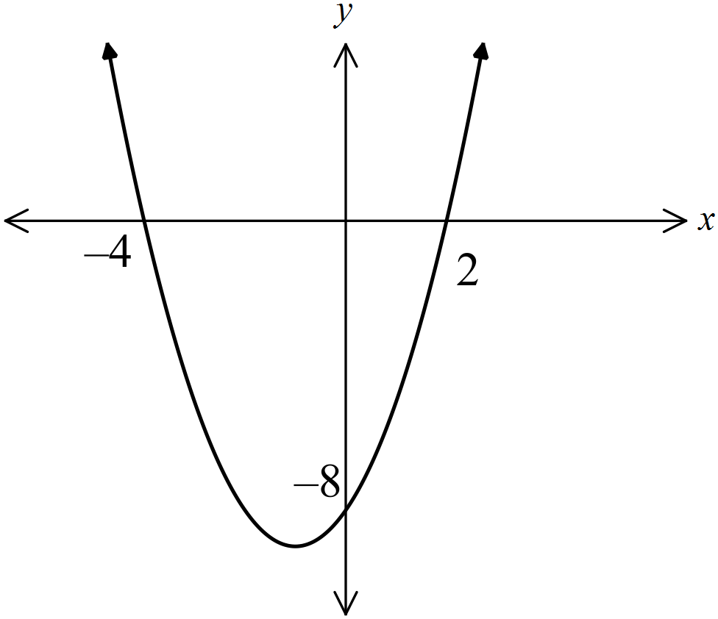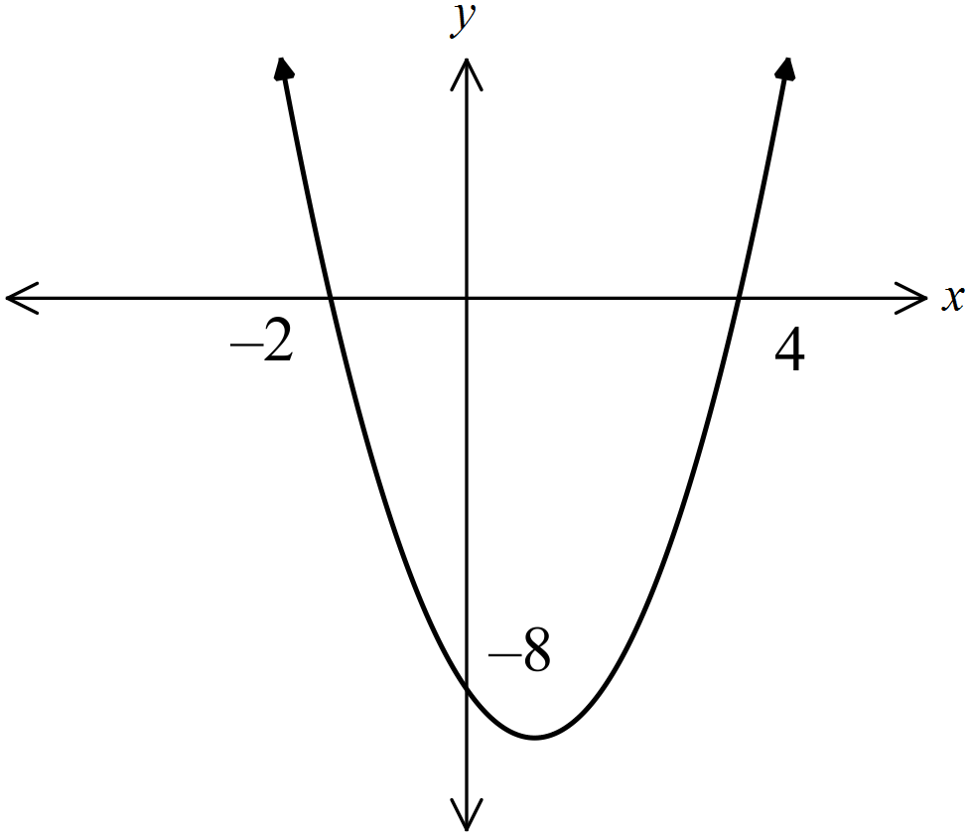 C. D.
70. | 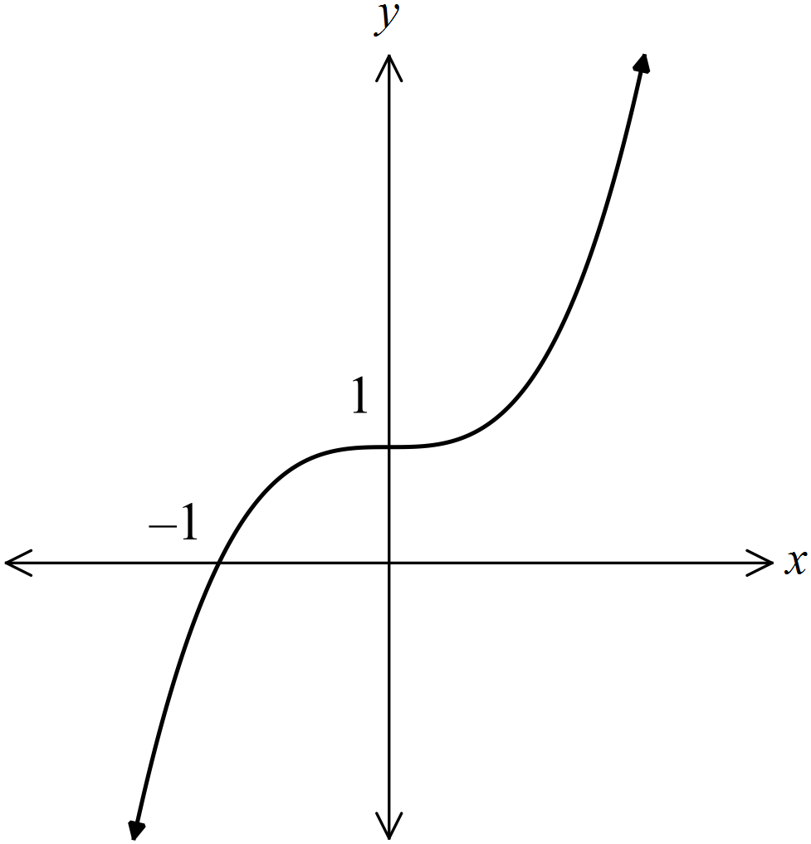Which equation could describe the curve shown on the graph?  A. 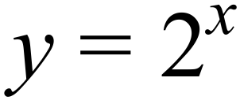  B. 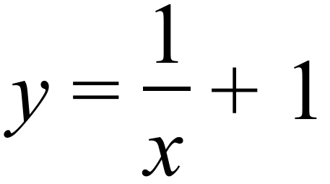  C. 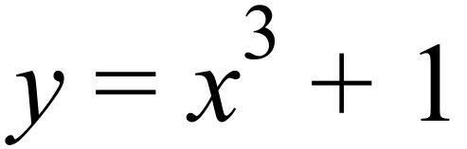  D. 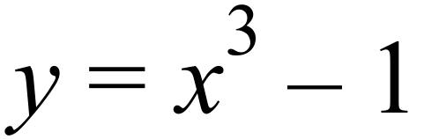
71. | If one letter is selected at random from those making up the word EXCITEMENT, what is the probability that it is not a vowel (I or E)?  A. 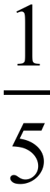 B. 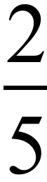 C. D. 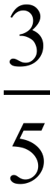
72. | Alex observes people leaving a supermarket to see if they are using reusable bags or are using the plastic bags provided by the supermarket. He compiled the table below.  If one person is chosen at random, leaving the supermarket, what is the probability that they are a male using a reusable bag?  A. 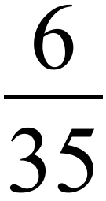 B. 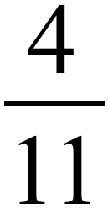 C. D. 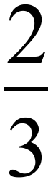
   | Male | Female | Total
  Reusable Bag | 12 | 21 | 33
  Plastic Supermarket Bag | 18 | 19 | 37
  Total | 30 | 40
73. | 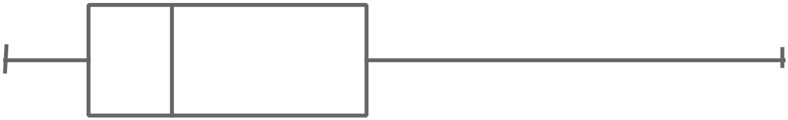Which box plot could represent a skewed set of data?  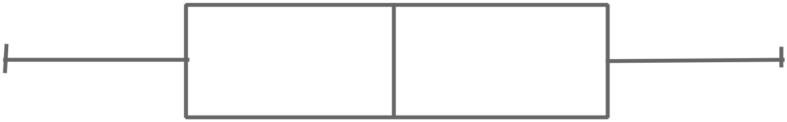 A. B.  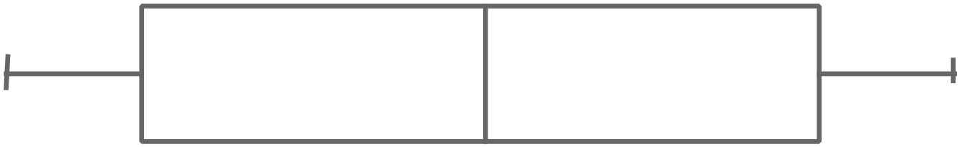  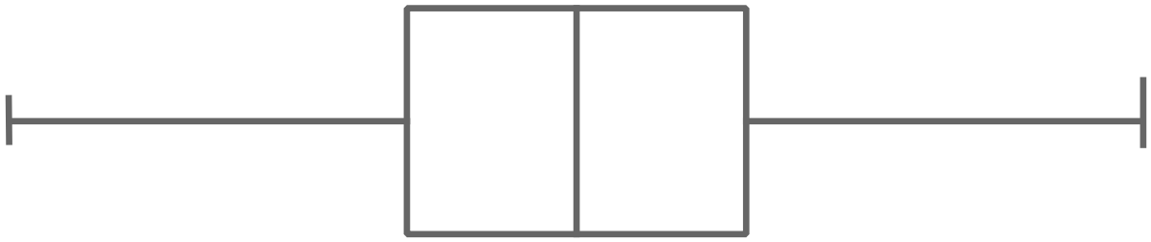 C. D.
74. | What is the interquartile range of the scores shown in the dot plot?  A. 3  B. 6  C. 7  D. 9
  Frequency |  |  |  | O
  Frequency |  |  |  | O
  Frequency |  |  | O | O
  Frequency |  | O | O | O | O |  |  | O
  Frequency | O | O | O | O | O | O | O | O | O
  Frequency | 4 | 5 | 6 | 7 | 8 | 9 | 10 | 11 | 12
  Score
75. | What are the mean and standard deviation of the scores below?  5, 5, 6, 8, 2, 8, 6, 9, 7, 9, 8, 2.  A. Mean = 6.25 and standard deviation = 2.3  B. Mean = 6.25 and standard deviation = 3.0  C. Mean = 6.5 and standard deviation = 2.3  D. Mean = 6.5 and standard deviation = 3.0

Section 2  Part B  Longer Answer Section |  | Name : _______________________________
 |  | Class/Teacher___________________________
Write all working and answers in the spaces provided on this examination paper.
Calculators are allowed for this section.

 |  | Marks
76. a) | Arrange these numbers in ascending order.  ……………………………………………………………………………………………  …………………………………………………………………………………………… | 2
b) | Express 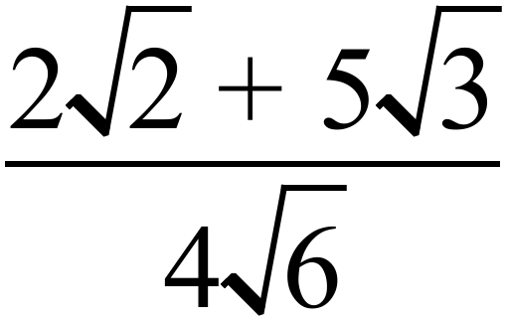 as a fraction with a rational denominator.  ……………………………………………………………………………………………  …………………………………………………………………………………………… | 1
77. | 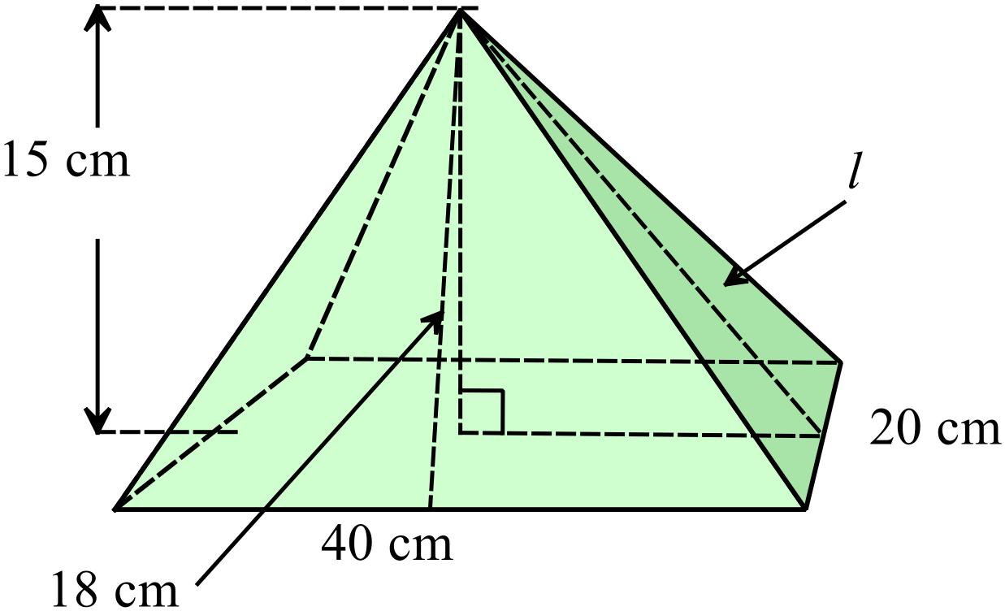The rectangular pyramid has the dimensions shown. The slant height of the front triangular face is 18 cm.
a) | Calculate the slant height ( l ) of the side triangular face.  ………………………………………………………………………………………….  ……………………………………………………………………………………………. | 1
b) | Find the volume of the pyramid.  …………………………………………………………………………………………….  …………………………………………………………………………………………. | 1
c) | Find the surface area of the pyramid.  …………………………………………………………………………………………….  …………………………………………………………………………………………….  ……………………………………………………………………………………………. | 1
78. | 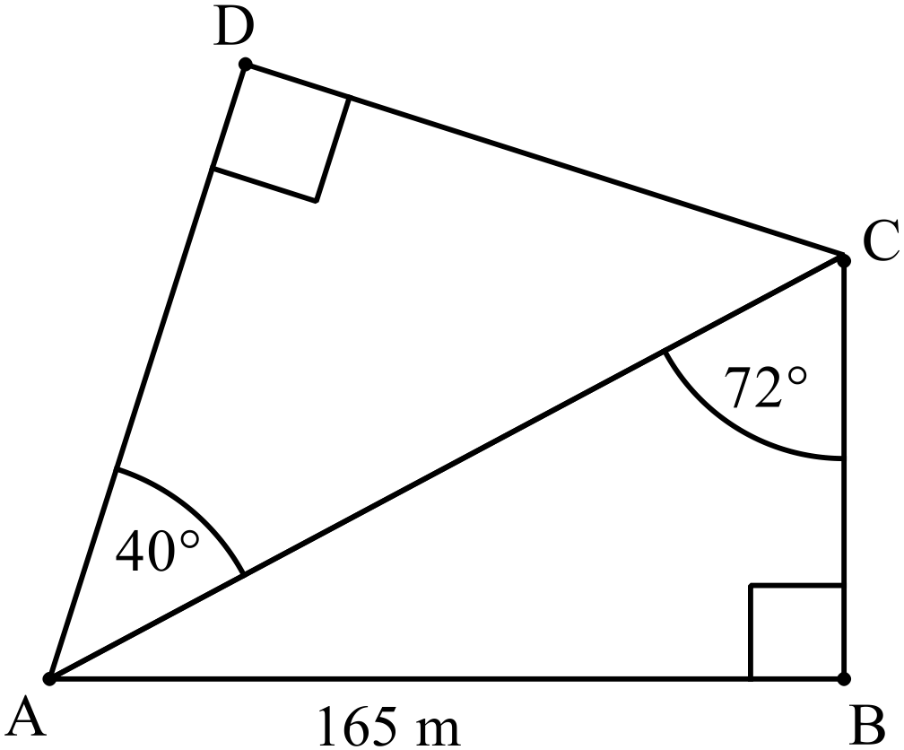A plan of a field ABCD is shown.  AB = 165 m.  Find the length of AD.  Answer to the nearest 10th of a metre.  …………………………………………………………………………………………  …………………………………………………………………………………………  …………………………………………………………………………………………  ………………………………………………………………………………………… | 3
79. a) | Jordie deposits $6 000 into a term deposit. The account earns interest at the rate of 4.4% p.a. compounding quarterly. If he invests the money for a term of 9 months, how much interest will he earn?  ……………………………………………………………………………………………  ……………………………………………………………………………………………  …………………………………………………………………………………………… | 1
b) | A smart phone is bought for $680.00, and depreciates at 18% p.a. compounded monthly. What is its value after 6 months?  ……………………………………………………………………………………………  ……………………………………………………………………………………………  …………………………………………………………………………………………… | 1
80. a) | ……………………………………………………………………………………………  …………………………………………………………………………………………… | 1
b) | 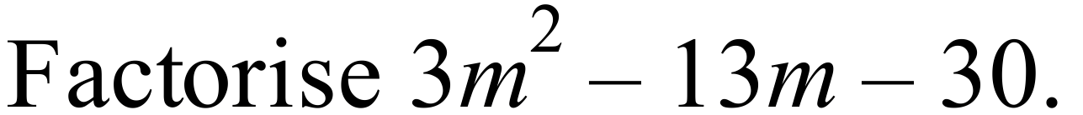  ……………………………………………………………………………………………  …………………………………………………………………………………………… | 1
c) | 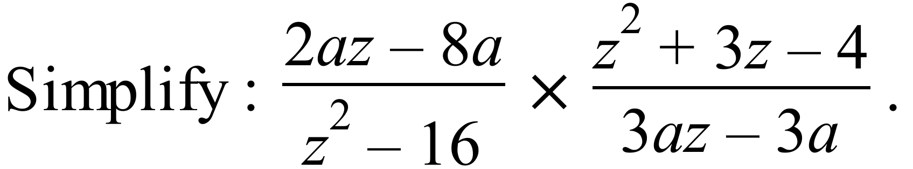  ……………………………………………………………………………………………  ……………………………………………………………………………………………  …………………………………………………………………………………………… | 2
81. a) | Solve 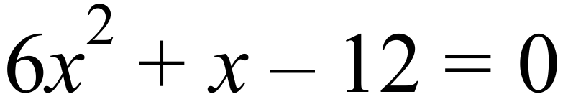  ……………………………………………………………………………………………  ……………………………………………………………………………………………  …………………………………………………………………………………………… | 1
b) | Solve 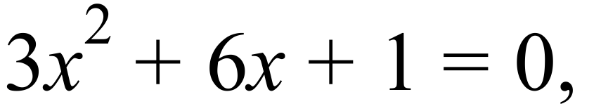 correct to 3 significant figures.  ……………………………………………………………………………………………  ……………………………………………………………………………………………  ……………………………………………………………………………………………  …………………………………………………………………………………………… | 2
82. a) | Show that the parabola 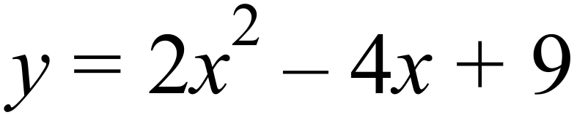 has no intercepts on the x axis.  ……………………………………………………………………………………………  …………………………………………………………………………………………… | 1
b) | Determine the turning point of the parabola 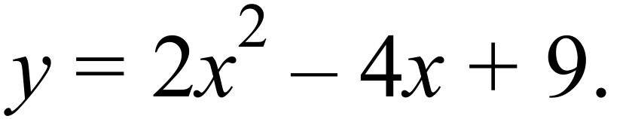  ……………………………………………………………………………………………  …………………………………………………………………………………………… | 1
c) | Draw a sketch of the parabola  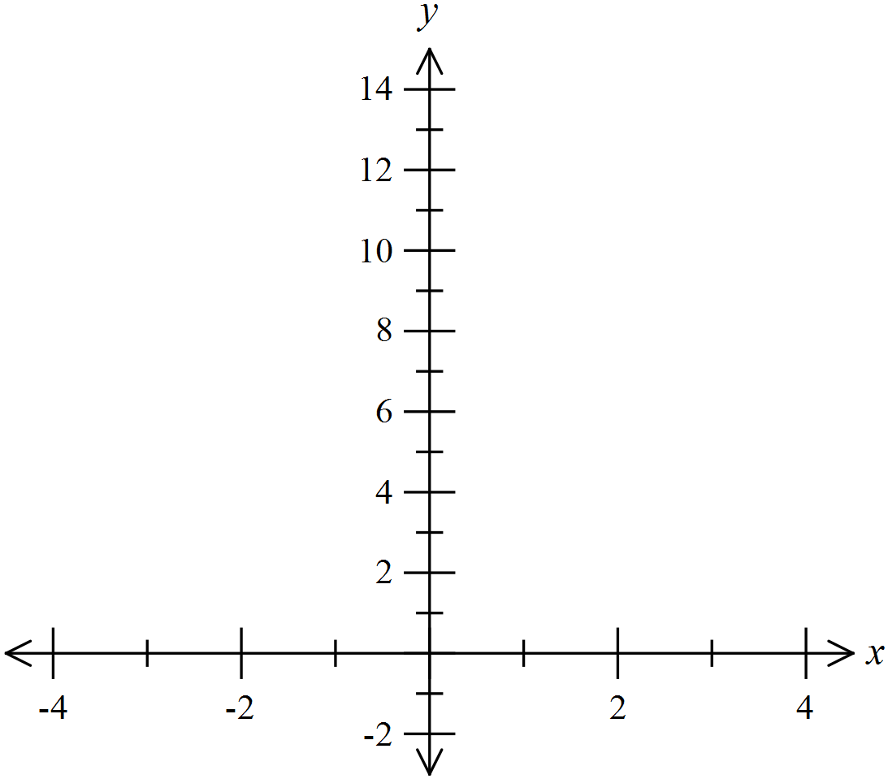  ……………………………………………………………………………………………  …………………………………………………………………………………………… | 2
83. | The results of two test groups on a trial of a pain relief drug are shown on the back to back stem and leaf plot.  The scores indicate the perceived amount of pain on a scale of 0 (low) to 70 (high).  Group A were the control group, and Group B took the drug being tested.  For Group A the mean was calculated to be 34.1 with a standard deviation of 15.0.  Group A Group B | 3
   |  |  |  |  | 2 | 0 | 2 | 3 | 5 | 6 | 7
   |  |  | 6 | 4 | 0 | 1 | 3 | 4 | 6 | 6 | 8 | 9
   | 8 | 6 | 5 | 3 | 1 | 2 | 3 | 4 | 4 | 5 | 9
  9 | 8 | 6 | 4 | 2 | 0 | 3 | 0 | 4 | 8 | 9
   | 8 | 6 | 5 | 3 | 1 | 4 | 2 | 4
   |  |  | 7 | 3 | 0 | 5 | 0
   |  |  |  |  | 2 | 6 | 1
a) | Find the mean and standard deviation for Group B.  ……………………………………………………………………………………………  …………………………………………………………………………………………… | 2
b) | Use statistical measures and terminology to analyse the results of the trial and determine if the drug appears to be successful in its aim, to reduce pain.  ……………………………………………………………………………………………  ……………………………………………………………………………………………  ……………………………………………………………………………………………  ………………………………………………………..………………………………… | 1

High School
Half - Yearly Exam
Advanced Mathematics Course
Multiple Choice Section Answer Sheet
Name ________________________________ Teacher ________________________
Completely fill the response oval representing the most correct answer.

26. A B C D
27. A B C D
28. A B C D
29. A B C D
30. A B C D
31. A B C D
32. A B C D
33. A B C D
34. A B C D
35. A B C D
36. A B C D
37. A B C D
38. A B C D
39. A B C D
40. A B C D
41. A B C D
42. A B C D
43. A B C D
44. A B C D
45. A B C D
46. A B C D
47. A B C D
48. A B C D
49. A B C D
50. A B C D

51. A B C D
52. A B C D
53. A B C D
54. A B C D
55. A B C D
56. A B C D
57. A B C D
58. A B C D
59. A B C D
60. A B C D
61. A B C D
62. A B C D
63. A B C D
64. A B C D
65. A B C D
66. A B C D
67. A B C D
68. A B C D
69. A B C D
70. A B C D
71. A B C D
72. A B C D
73. A B C D
74. A B C D
75. A B C D

